Experiment 9.1
Discrete Fourier Transform
Test Case: Discrete Fourier Transform (DFT) of a Discrete-Time Signal
Aim:
To compute and visualize the Discrete Fourier Transform (DFT) of a discrete-time
signal. The DFT converts a discrete-time signal from the time domain to the
frequency domain, providing insights into the frequency components of the signal.
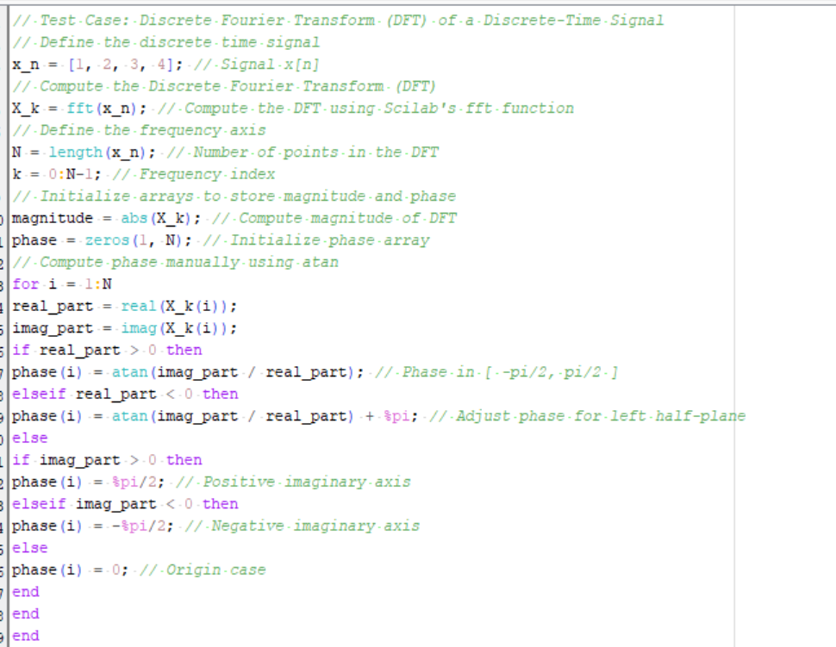
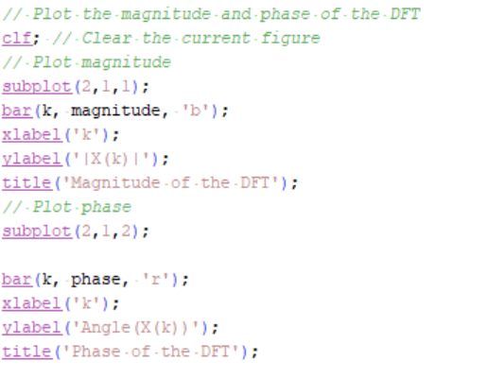
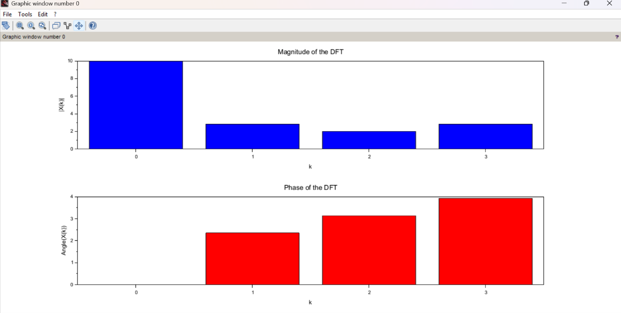
Experiment 9.4
FFT – Decimation-In-Frequency (DIF) Algorithm
Aim:
To compute the Fast Fourier Transform (FFT) of a discrete-time signal using the
Decimation-In-Frequency algorithm in Scilab.
